**MANAGEMENT PRINVIPLES ENGINEERING**

**CT-3 QUESTION BANK**

**PART -A::**

**[UNIT-4]**

1. _____ is a market where a small number of competitors feel themselves constrained more by the actions of their rivals

a) Monopoly environment b) Oligopoly environment

c) Hyper competition d) none of a or b or c

2. ____ using resources well to operate at low cast

a) Financial Health b) Human talent

c) Product quality d) Cost efficiency

3. Analysis of organisational resources and capabilities the strength and weakness are measured in the _____

a) Internal assessment of the organisation b) External assessment of the environment ‘

c) Weak market rivals d) New regulations

4. Intensity of rivalry among firms in the industry are _____

a) Substitutes b) New entrants

c) Industry competitors d) Customers

5. Threat of New Entrants affecting industry competition is due to ___

a) High competition b) Low entry barriers

c) Demand for the company’s products to continue in long term

d) Higher bargaining power

6. Single business or a component that operates with a separate mission with a larger enterprise is called

a) Corporate strategy b) Functional strategy

c) Strategic business unit d) None of a or b or c

7. Liquidation is

a) Growth strategy b) diversification strategy

c) Retrenchment strategy d) vertical integration

8. To continuously improve the operating efficiency of production distribution and other organisational system is _____

a) cost leadership strategy b) differentiation strategy

c) source of competitive advantage d) focused differentiation strategy

9. The term emergent strategies is referred by

a) Mintzberg b) Maslow

c) Alderfer d) Peter Drucker

10. The system of control and performance monitoring of top management by boards of directors and other major stake holders representatives is

a) Management practices and systems b) Corporate governance

c) Strategic leadership d) Strategic implementation

**[UNIT-5]**

11. Making a distinction between individuals or groups so as to advantage some and disadvantage others

a) Strategic HRM b) Discrimination

c) HR Planning d) People management

12. The information in a job analysis used to write and or update with writter statement in a job duties and responsibilites is called

a) Job description b) Human resource objectives

c) HR planning d) Forecasting human resource needs

13. Objectives are set, regularly assessed for accomplishment and that actions are taken to improve the capability in the future is termed as

a) Performance management system b) Management Delvelopment

c) Training and development d) Mentoring

14. Focusing on a subordinate’s developmental needs

a) Judgemental role b) Counselling role

c) Development purpose d) Evaluation purpose

15. Each person is compared with every other person and rated as either the superior or the weaker member

a) Rank ordering b) Multiperson comparisons

c) Paired comparisons d) Forced distribution

16. Inflation, Interest rates, income levels, gross domestic product and related indicators are ______

a) Sociocultural conditions b) Natural environment conditions

c) Economic conditions d) Political legal conditions

17. One of the criteria, where in the core values of the organisation meet and the values should be known by all members of the organisation or group

a) Relevance b) Pervasiveness

c) Symbols d) None of a (or) b (or) c

18. The behaviour that would be considered ethical from the perspective greatest good to the greatest number of people

a) Utilitarian view b) Leadership view

c) Language metaphors d) Heroes

19. A manager has privileged information regarding the activites of a customer and shares that information with another party

a) Organisational resource b) conflicts of interest

c) Customer confidence d) discrimination

20. People who expose the misdeeds of other in organisations in order to preserve ethical standards and protect against wasteful, harmful or illegal acts

a) Whistle blowers b) Problem seekers

c) Problem solvers d) symbolic leader

**PART-B**

1.What are the operating objectives of a business might include according to Peter Drucker? [unit-4]

**ANS:: operating objectives** direct activities towards specific performance results. These objectives are shorter term targets against which actual performance results can be measured as indicators of progress and continuous improvement. Any and all operating objectives should have clear means–ends links to the mission and purpose. Any and all strategies should, in turn, offer clear and demonstrable opportunities to accomplish operating objectives.

According to Peter Drucker, the operating objectives of a business might include:

i. *profitability* — producing at a profit in business

ii. *market share* — gaining and holding a specific market share

iii. *human talent* — recruiting and maintaining a high‐quality workforce

iv. *financial health* — acquiring capital; earning positive returns

v. *cost efficiency* — using resources well to operate at low cost

vi. *product quality* — producing high‐quality goods or services

vii. *innovation* — developing new products and/or processes

viii. *social responsibility* — making a positive contribution to society.

2.What are the key resource areas in the strategy formulation and implementation in the strategic management process? [unit-4]

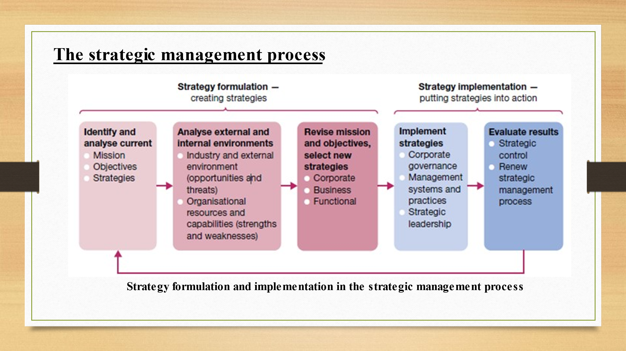

3.How well the mission statement serves the organization's external stake holders in the strategic Management process? [unit-4]

ANS:: A good mission statement identifies the domain in which the organisation intends to operate —including the customers it intends to serve, the products and/or services it intends to provide, and the location in which it intends to operate. The mission statement should also communicate the underlying philosophy that will guide employees in these operations. For example Consider the mission statement for Merck, one of the world’s leading pharmaceutical companies: ‘To discover, develop and provide innovative products and services that save and improve lives around the world’.

An important test of corporate purpose and mission is how well it serves the organisation’s **stakeholders**. Stakeholders are individuals and groups — customers, shareholders, suppliers, creditors, community groups and others — who are directly affected by the organisation and its accomplishments.

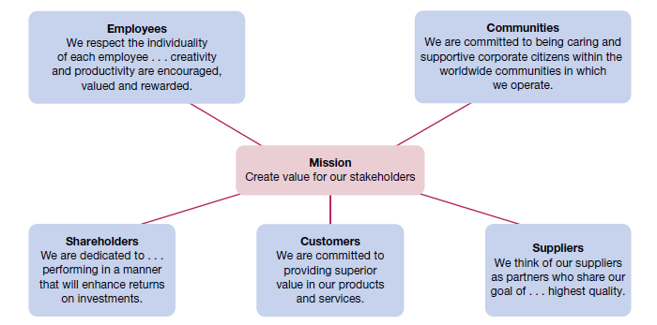

**Fig 4.3.2 External stakeholders and the mission statement**

In the strategic management process, the stakeholder test can be done as a constituencies analysis. Here, the specific interests of each stakeholder are assessed along with the organisation’s record in responding to them. Figure above gives an example of how stakeholder interests can be reflected in a mission statement

4.Do a SWOT analysis of Internal assessment of the organization and external assessment of the environment in the

strategic management process. [unit-4]

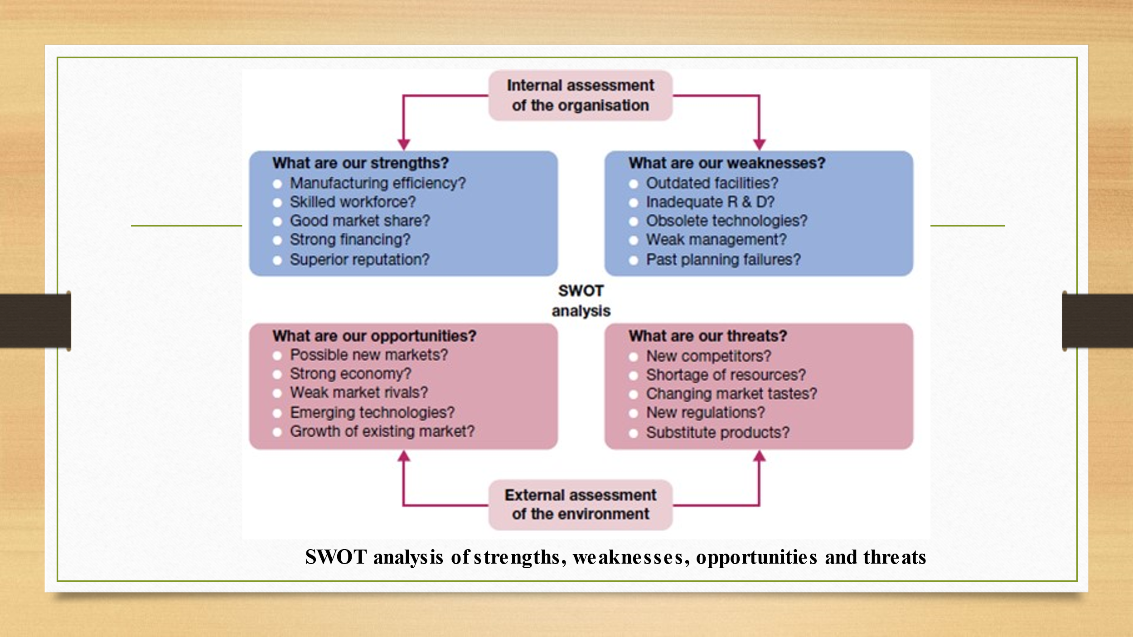

A SWOT analysis is not complete until opportunities and threats in the external environment are also analysed. They can be found among *macroenvironment factors* such as technology, government, social structures and population demographics, the global economy and the natural environment. They can also include developments in the *industry environment* of resource suppliers, competitors and customers. Opportunities may exist as possible new markets or a strong economy; threats may be identified in such things as the emergence of new competitors or technologies, resource scarcities, changing customer tastes and new government regulations, among other possibilities.

In respect to the external environment as a whole, the more stable and predictable it is, the more likely that a good strategy can be implemented with success for a longer period of time, but when the environment is composed of many dynamic elements that create uncertainties, more flexible strategies that change with time are needed. Given the nature of competitive environments today, strategic management must be considered an ongoing process in which strategies are formulated, implemented, revised and implemented again in a continuous manner.

5. Which of the areas the need for the sustainable competitive advantage are found? How they contribute while formulating strategy? [unit-4]

The major *opportunities for competitive advantage* are found in the following areas:

i. *cost and quality* — where strategy drives an emphasis on operating efficiency and/or product or service quality

ii. *knowledge and speed* — where strategy drives an emphasis on innovation and speed of delivery to market for new ideas

iii. *barriers to entry* — where strategy drives an emphasis on creating a market stronghold that is protected from entry by others

iv. *financial resources* — where strategy drives an emphasis on investments and/or loss sustainment that competitors can’t match.

Importantly, any advantage gained in today’s global and information‐age economy of intense competition must always be considered temporary, at best. Things change too fast. Any advantage of the moment will sooner or later be eroded as new market demands, copycat strategies and innovations by rivals take their competitive toll over time. The challenge of achieving sustainable competitive advantage is thus a dynamic one.

6. Explain about the different types of strategies in adoptive strategies. [unit-4]

**Adaptive strategies**

The Miles and Snow adaptive model of strategy formulation suggests that organisations should pursue product/market strategies congruent with their external environments. A well‐chosen strategy, in this sense, allows an organisation to successfully adapt to environmental challenges.

The *prospector strategy* involves pursuing innovation and new opportunities in the face of risk and with prospects for growth. This is best suited to a dynamic and high‐potential environment. A prospector ‘leads’ an industry by using existing technology to new advantage and creating new products to which competitors must respond. This contrasts with a *defender strategy*, in which an organisation avoids change by emphasising existing products and current market share without seeking growth. Defence as a strategy is suited only for a stable environment and perhaps declining industries. Defenders, as do many small local retailers, try to maintain their operating domains with only slight changes over time. As a result, many suffer long‐term decline in the face of competition.

The *analyser strategy* seeks to maintain the stability of a core business while exploring selective opportunities for innovation and change. This strategy lies between the prospector and reactor strategies. It is a ‘follow‐the‐leader‐when‐things‐look‐good’ approach. Many of the ‘clone’ makers in the personal computer industry are analysers; that is, they wait to see what the industry leaders do and how well it works out before modifying their own operations.

Organisations pursuing a *reactor strategy* are mainly responding to competitive pressures in order to survive. This is a ‘follow‐as‐last‐resort’ approach. Reactors do not have long‐term and coherent strategies. Some public utilities and other organisations operating under government regulation may use this strategy to some extent.

7. Write a note on the management practices and systems and the pitfalls during strategic planning and implementation. [unit-4]

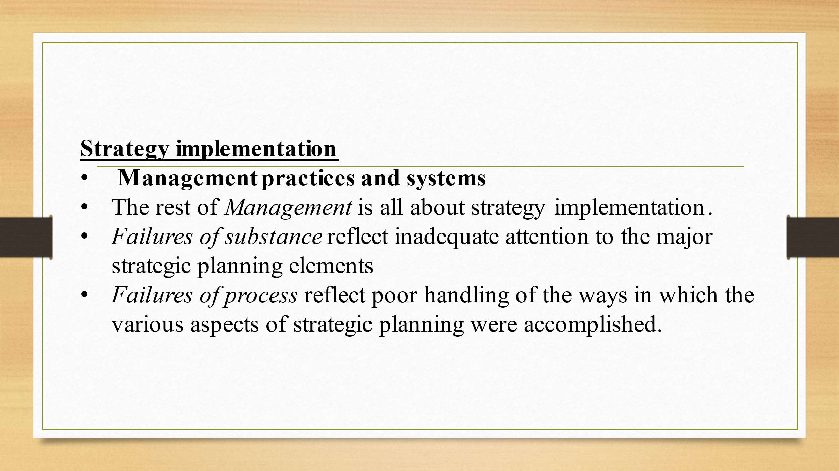

OR

**Management practices and systems**

The rest of *Management* is all about strategy implementation. In order to successfully put strategies into action the entire organisation and all its resources must be mobilised in support of them. This, in effect, involves the complete management process from planning and controlling through organising and leading. No matter how well or elegantly selected, a strategy requires supporting structures, the right technology, a good allocation of tasks and workflow designs, and the right people to staff all aspects of operations. The strategy needs to be enthusiastically supported by leaders who are capable of motivating everyone, building individual performance commitments, and using teams and teamwork to best advantage. And the strategy needs to be well and continually communicated to all relevant persons and parties. Only with such total systems support can strategies succeed in today’s environments of change and innovation.

Common strategic planning pitfalls that can hinder implementation include both failures of substance and failures of process. *Failures of substance* reflect inadequate attention to the major strategic planning elements — analysis of mission and purpose, core values and corporate culture, organisational strengths and weaknesses, and environmental opportunities and threats. *Failures of process* reflect poor handling of the ways in which the various aspects of strategic planning were accomplished. An important process failure is the *lack of participation error*. This is failure to include key people in the strategic planning effort. As a result, their lack of commitment to all‐important action follow‐through may severely hurt strategy implementation. Process failure also occurs with too much centralisation of planning in top management or too much delegation of planning activities to staff planners or separate planning departments. Another process failure is the tendency to get so bogged down in details that the planning process becomes an end in itself instead of a means to an end. This is sometimes called ‘goal displacement’.

Recent research on strategy implementation has identified that information flow and decision rights are two of the most important drivers in strategy execution.75 Clarification on what decisions and actions each person in the organisation is responsible for is one of the most important factors in strategy implementation. Also, in terms of decision rights, once decisions are made they should only rarely be second‐guessed, as second‐guessing tends to slow down implementation. In terms of information flow, information about the competitive environment must flow to headquarters quickly and information must flow freely across organisational boundaries.

8.Explain the steps in strategic HR planning. [unit-5]

Strategic HRM Any organisation should at all times have the right people available to do the work required to achieve and sustain competitive advantage. Strategic HRM applies the HRM process to ensure the effective accomplishment of the organisation’s mission. Strategic HRM mobilises human resources to implement strategies and sustain competitive advantage. This requires a top‐level commitment to HR planning, a process of analysing staffing needs and planning how to satisfy these needs in a way that best serves the organisation’s mission, objectives and strategies. The major elements in strategic human resource planning are shown in figure. The process begins with a review of the organisation’s mission, objectives and strategies. This establishes a frame of reference for forecasting HR needs and labour supplies, both within and outside the organisation. Ultimately, the planning process should help managers identify staffing requirements, assess the existing workforce, and determine what additions and/or replacements are required to meet future needs.

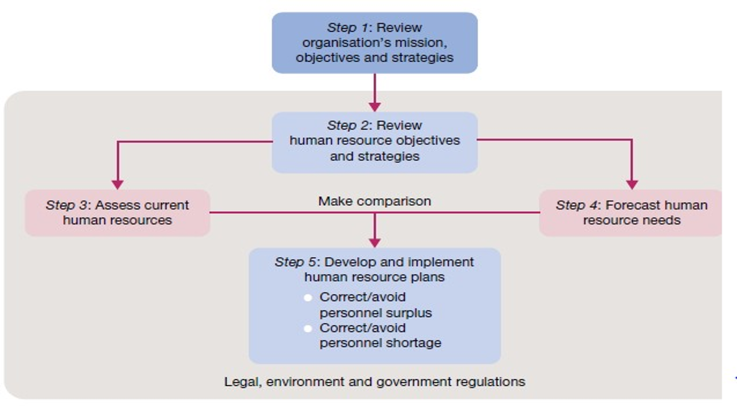

Fig 5.1.1 Steps in strategic HR planning

9.Discuss the steps in the selection process in the case of a rejected job applicant. [unit-5]

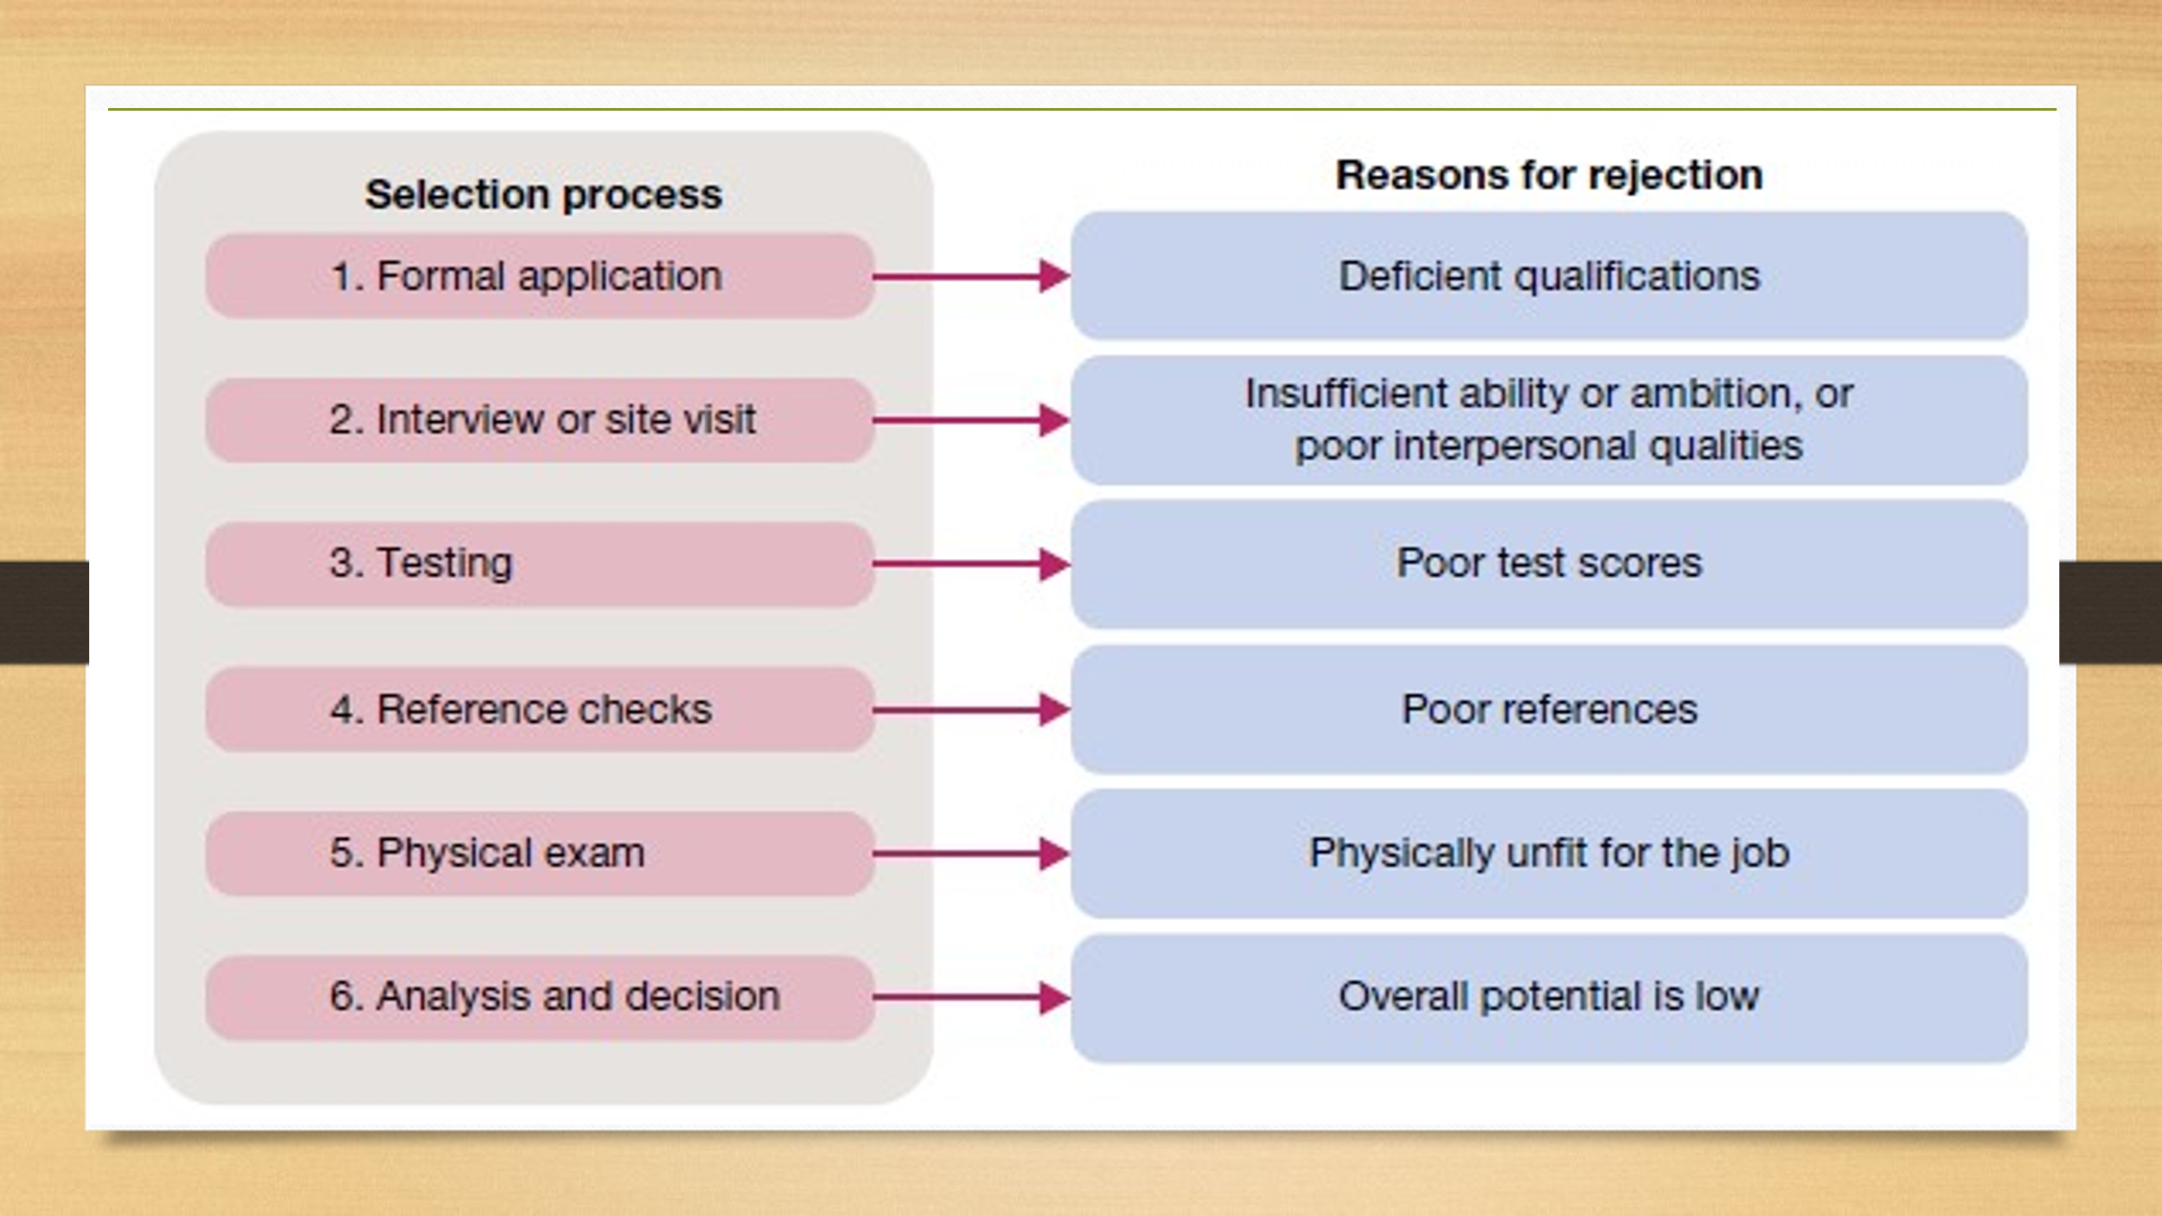

10. What is competitive advantage with regard to human resource management? [unit-5]

Astute executives are ever alert to environmental trends that require adjustments in the ways their organisations operate and that offer opportunities to achieve competitive advantage. This term refers to the use of a core competency that clearly sets an organisation apart from its competitors and gives it an advantage over them in the marketplace. Simply put, competitive advantage comes from an ability to do things better than your competitors. An organisation may achieve competitive advantage in many ways, including through its products, pricing, customer service, cost efficiency, quality, and even diversity, among other aspects of operating excellence. But regardless of how the advantage is achieved, the key result is the same — an ability to consistently do something of high value that your competitors cannot replicate quickly or do as well.

11.Write a note on the Leadership and organisational culture.

[unit-5]

Leadership and organisational culture Leadership of the organisational culture involves establishing and maintaining appropriate core values. Although this is most often considered a top management job, the same requirement holds for any manager or team leader at any level of responsibility. Just like the organisation as a whole, any work team or group will have a culture. How well this culture operates to support the group and its performance objectives will depend in part on the strength of the core values. At any level, these values should meet the test of three criteria:

1. relevance — core values should support key performance objectives;
2. pervasiveness — core values should be known by all members of the organisation or group; and

(iii) strength — core values should be accepted by everyone involved.

Attention is increasingly being given to the concept of a symbolic leader — someone who uses symbols well to establish and maintain a desired organisational culture. Symbolic managers and leaders talk the ‘language’ of the organisation. They are always careful to use spoken and written words to describe people, events and even the competition in ways that reinforce and communicate core values.

21 Language metaphors — the use of positive examples from another context — are very powerful in this regard. Good symbolic leaders highlight the observable culture. They tell key stories over and over again, and they encourage others to tell them. They often refer to the ‘founding story’ about the entrepreneur whose personal values set a key tone for the business. They often talk about organisational heroes, past and present, whose performances exemplify core values. They often use symbolic rites and rituals that glorify the performance of the organisation and its members.

12.What are the ethical problems specifically faced by managers?

[unit-5]

Ethical problems faced by managers There are many potential sources of discomfort in managerial decision‐making, including those with ethical overtones. Some of the problem areas or situations where managers can get caught in ethical dilemmas include:

• discrimination — where a manager denies promotion or appointment to a job candidate because of the candidate’s race, religion, gender, age or other criterion not relevant to the job

• sexual harassment — where a manager makes a co‐worker feel uncomfortable because of inappropriate comments or actions regarding sexuality.

• conflicts of interest — where a manager takes a bribe or kickback or extraordinary gift in return for making a decision favourable to the gift giver

• customer confidence — where a manager has privileged information regarding the activities of a customer and shares that information with another party

• organisational resources — where a manager uses official stationery or a company email account to communicate personal opinions or requests to community organisations.

Often many of the ethical dilemmas reported by managers involved conflicts with superiors, customers and subordinates. The most frequently occurring issues involved dishonesty in advertising and communications with top management, clients and government agencies. problems in dealing with special gifts, entertainment and kickbacks.

13. Explain the roles of whistle blowers and about the whistle blower protection. [unit-5]

Whistleblowers, are people who expose the misdeeds of others in organisations in order to preserve ethical standards and protect against wasteful, harmful or illegal acts. Whistleblowers face the risks of impaired career progress and other forms of organisational retaliation, up to and including dismissal.

Many workers become whistleblowers unintentionally when reporting workplace fraud, corruption or maladministration. But although signs indicate that the courts are growing supportive of whistleblowers, legal protection for them can still be inadequate.

Laws vary from state to state, and federal laws mainly protect government workers. Furthermore, even with legal protection, potential whistleblowers may find it hard to expose unethical behaviour in the workplace.

Some organisational barriers to whistleblowing include 28 a strict chain of command that makes it hard to bypass the boss, strong work group identities that encourage loyalty and self‐censorship, and ambiguous priorities that make it hard to distinguish right from wrong.

In the attempt to remove these and other blocks to the exposure of unethical behaviours, some organisations have formally appointed staff members to serve as ‘ethics advisers’. Others have set up formal staff units to process reported infractions. One novel proposal goes so far as to suggest the convening of moral quality circles to help create shared commitments for people to work at their moral best

14.Which are the areas, specifically the code of vendor conduct deals in a vendor code document? [unit-5]

A sample formal Code of Vendor Conduct, among the many areas covered, the document specifically deals with:

• discrimination — stating ‘Factories shall employ workers on the basis of their ability to do the job, not on the basis of their personal characteristics or beliefs’

• forced labour — stating ‘Factories shall not use any prison, indentured or forced labour’

• working conditions — stating ‘Factories must treat all workers with respect and dignity and provide them with a safe and healthy environment’

• freedom of association — stating ‘Factories must not interfere with workers who wish to lawfully and peacefully associate, organize or bargain collectively.

**PART-C**

1.Explain in detail about the Porter's model of strategic forces affecting industry competition. [unit-4]

ANS::

Michael Porter offers the five forces model as a way of adding sophistication to this analysis of the environment

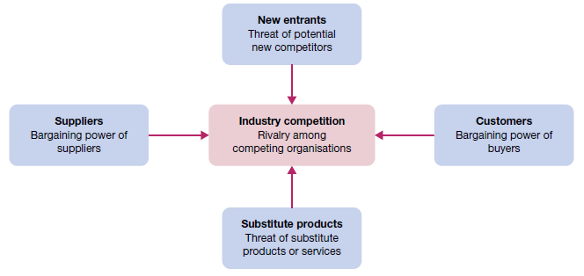

**Fig 4.3.4 Porter’s model of five strategic forces affecting industry competition**

Porter’s framework for competitive industry analysis directs attention towards understanding the following forces:

1. *industry competitors* — intensity of rivalry among firms in the industry

2. *new entrants* — threats of new competitors entering the market

3. *suppliers* — bargaining power of suppliers

4. *customers* — bargaining power of buyers

5. *substitutes* — threats of substitute products or services.

Michael Porter's Five Forces is a powerful competitive analysis tool to determine the principal competitive influence in a market. It is a broadly used model in business that refers to the five important factors that drive a firm's competitive position within an industry. By thinking through how each force affects you, and by identifying the strength and direction of each force, you can quickly assess the strength of the position and your ability to make a sustained profit in the industry. Thus Five Forces analysis helps the firm stay competitive by:

* Knowing the strength of these five forces, you can develop strategies that help their businesses be more competitive and profitable.
* Looking at opportunities, you can to strengthen their organization's position compared to the other players for reducing the competitive pressure as well as generate competitive advantage.

**Step-by-Step Five Forces Analysis**

Porter's Five Forces Analysis is an important tool in the project planning stage. Porter's Five Forces Analysis makes a strong assumption that there are only five important forces that could determine the competitive power in a business situation. Using the following three steps:

1. Identify the different factors that bring about the competitive pressures for each of the five forces:
   * Who are the suppliers?
   * Who are the customers?
   * What are the substitute products?
   * Is it difficult to enter this industry?
   * Who are the major competitors in this industry?
2. Based on the factors identified, determine if the pressures are:
   * Strong
   * Moderate
   * Weak
3. Determine whether the strength of the five forces is favorable to earning attractive profits in the industry. Using the Five Forces model can help answer the following questions:
   * Is the state of competition in the industry stronger than "normal"?
   * Can companies in this industry expect to earn decent profits in light of the competitive forces?
   * Are the competitive forces sufficiently powerful enough to undermine industry profitability?

2.Explain in detail about the effect on Internet on Porter's 5 strategic forces model.[unit-4]

**ANS::**

**The effect on Internet on Porter's 5 forces model**

**The entry of new competitors**

Today, it’s not just traditional industry competitors the firm needs to worry about, but new entrants from outside the industry, equipped with new digitally based business models and value propositions. This is often tech giants and startups that have envisioned and built a new business model from the ground up, powered by a new platform ecosystem for digital business. They’re leveraging the familiar social, mobile, analytics and cloud technologies, but are often adding in personas and context, intelligent automation, the Internet of Things, and cybersecurity to further enhance the value proposition of their platform.

Why can new entrants move in so easily? Digital business changes the rules by lowering the traditional barriers to entry. A digitally based business model requires far less capital and can bring large economies of scale for example.

**The threat of substitutes**

The threat of substitutes has to do with the threat of substitute products or services. In terms of internet based business, this can come from a purely digital substitute or a hybrid digital/physical substitute. Taxi services, such as Uber and EasyTaxi for example, provide a hybrid model via a digital app for consumers and taxi drivers, coupled with the physical taxis.

Digital services wrapped around a physical product are another example and can range from one extreme such as the industrial Internet to another such as home automation technologies or personal fitness products. In addition, the long-term revenue stream from the digital services may be worth far more than the one time sale of the physical product.

The threat of substitutes is high in many industries since switching costs are low and buyer propensity to substitute is high. In the taxi services example, customers can easily switch from traditional models to the new model simply by installing an app on their smartphone. Propensity to switch from the traditional model is high due to consumer wait times for taxis, lack of visibility into taxi location and so on.

**The bargaining power of buyers**

Perhaps the strongest of the five forces impacting industry competition is the bargaining power of buyers since the biggest driver of digital business comes from the needs and expectations of consumers and customers themselves.

This bargaining power lays out a new set of expectations for the digital customer experience and necessitates continual corporate innovation across business models, processes, operations, products and services.

Customers and consumers have amassed far more bargaining power today due to instant access to information, insights from social media including access to reviews and feedback, low switching costs via digital channels, price sensitivity, access to substitute products and services with greater ease of use and convenience, as well as increased industry competitiveness as a result of the other forces.

**The bargaining power of suppliers**

Suppliers can accelerate or slow down the adoption of a digitally based business model based upon how it impacts their own situation. Those pursuing digital models themselves, such as the use of APIs to streamline their ability to form new partnerships and manage existing ones, may help accelerate your own model.

Those who are suppliers to the traditional models, and who question or are still determining their new role in the digital equivalent, may use their bargaining power to slow down or dispute the validity or legality of the new model.

Good examples are the legal and business issues surfacing around the digital-sharing economy (i.e. ride-sharing, room-sharing etc.) where suppliers and other constituents work to ensure the business model and process innovations still adhere to established rules, regulations, privacy, security and safety. This is a positive and needed development since, coupled with bargaining power of buyers, it can help to keep new models “honest” in terms of how they operate.

**The rivalry among the existing competitors**

Finally, existing competitors are all looking at internet-based business, trying to understand the disruptions occurring, and prepare their response. The responses can range all the way from defensive to offensive measures, and even a first-mover attack. This rivalry among competitors is always in play, but in recent years digital business has added fuel to the fire, just as the e-business era did many years ago.

The rivalry is heating up because entry and exit barriers are going down due to the comparative low-cost of internet business models, and in many cases new entrants do not even need to own physical assets or infrastructure. In particular, the “platform” model is seeing considerable success in the marketplace by simply connecting stakeholders and applying a set of peripheral services to enhance the customer experience.

By doing so, platform operators are moving to the forefront of service delivery and getting closer to the customer without even owning assets or employees working in that particular industry. Today, any service provider, and even content provider, risks becoming hostage to the platform operator, which, by aggregating all those peripherals and streamlining the experience of using them, suddenly moves from the periphery to the centre.

3 Write detail notes on the different types of strategies in the corporate and business and also their functional strategies. [unit-4]

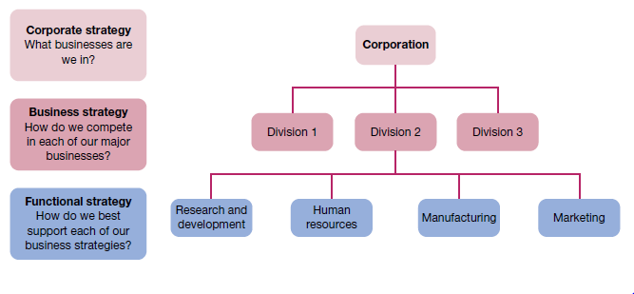

**Fig 4.4.1 Levels of strategy in organisations**

**Levels of strategy**

The level of **corporate strategy** directs the organisation as a whole towards sustainable competitive advantage. For a business it describes the scope of operations by answering the following question: In what industries and markets should we compete? The purpose of corporate strategy is to set direction and guide resource allocations for the entire enterprise. In large, complex organisations like General Electric (GE), corporate strategy identifies the different areas of business in which a company intends to compete. The organisation presently pursues business interests in aviation, home and businesses solutions, financial (capital) services, healthcare, energy and transportation, for example. Typical strategic decisions at the corporate level relate to the allocation of resources for acquisitions, new business development, divestitures and so on across the business portfolio. Increasingly, corporate strategies for many businesses include an important role for global operations such as international joint ventures and strategic alliances.

**Business strategy** is the strategy for a single business unit or product line. It describes intent to compete within a specific industry or market. Large conglomerates such as GE, are composed of many businesses, with many differences among them in product lines and even industries. The term **strategic business unit (SBU)** is often used to describe a single business or a component that operates with a separate mission within a larger enterprise. The selection of strategy at the business level involves answering the question: How are we going to compete for customers in this industry and market? Typical business strategy decisions include choices about product/service mix, the location of facilities and new technologies.

**Functional strategy** guides the use of organisational resources to implement business strategy. This level of strategy focuses on activities within a specific functional area of operations. The standard business functions of marketing, manufacturing, human resources, and research and development illustrate this level of strategy. The question to be answered in selecting functional strategies becomes: How can we best use resources to implement our business strategy? Answers to this question typically involve the choice of progressive management and organizational practices that improve operating efficiency, product or service quality, customer service or innovativeness.

**Growth and diversification strategies**

Traditionally one of the most common and popular of the grand or master strategies pursued by organizations at the corporate or business levels is growth. **Growth strategies** pursue an increase in size and the expansion of current operations. They are popular in part because growth is viewed as necessary for long-term survival in some industries.

One approach to growth is through **concentration**, where expansion is within the same business area. Another approach to growth is through **diversification**, where expansion takes place through the acquisition of, or investment in, new and sometimes different business areas. A strategy of *related diversification* involves growth by acquiring new businesses or entering business areas that are related to what the organisation already does. This strategy seeks the advantages of growth in areas that use core competencies and existing skills. A corporate strategy of *unrelated diversification* involves growth by acquiring businesses or entering business areas that are different from what the organisation already does. Occasionally, a company will invest in a market that is completely unrelated to its current operations.

Diversification can also take the form of **vertical integration**, where a business seeks added value creation by acquiring suppliers (*backwards vertical integration*) or distributors (*forwards vertical integration*). In the car making industry, backwards vertical integration has been common as firms purchased suppliers of key parts to ensure quality and control over their availability. In beverages, both Coca Cola and PepsiCo have pursued forward vertical integration by purchasing some of their major bottlers.

There is a tendency to equate growth with effectiveness, but that is not necessarily true. Any growth strategy, whether by concentration or some form of diversification, must be well planned and well managed to achieve the desired results. Increased size of operation in any form adds challenge to the management process. Diversification, in particular, brings the difficulties of complexity and the need to manage and integrate very dissimilar operations. Research indicates that business performance may decline with too much unrelated diversification.

**Restructuring and divestiture strategies**

When organisations experience performance problems, perhaps due to unsuccessful diversification, retrenchment of some sort often takes place. The most extreme **retrenchment strategy** is *liquidation*, when operations cease, owing to the complete sale of assets or the declaration of bankruptcy. Less extreme but still of potential dramatic performance impact is **restructuring**. This changes the scale and/ or mix of operations in order to gain efficiency and improve performance. The decision to restructure can be difficult for managers to make because, at least on the surface, it seems to be an admission of failure. But in today’s era of challenging economic conditions and environmental uncertainty, restructuring is used frequently and with new respect.

Restructuring is sometimes accomplished by **downsizing**, which decreases the size of operations with the intention of becoming more streamlined. The expected benefits are reduced costs and improved operating efficiency. A common way to downsize is to cut the size of the workforce. Research has shown that such downsizing is most successful when the workforce is reduced in a way that allows for better focusing of resources on key performance objectives. Retrenchment with a strategic focus is sometimes referred to as *rightsizing*. This contrasts with the less well regarded approach of simply cutting staff ‘across the board’.

Restructuring by **divestiture** involves selling off parts of the organisation to refocus on core competencies, cut costs and improve operating efficiency. This is a common strategy for organisations that find they have become overdiversified and are encountering problems managing the complexity of diverse operations. It is also a way for organisations to take advantage of the value of internal assets by ‘spinning off’ or selling to shareholders a component that can stand on its own as an independent business.

**Cooperation in business strategies**

In recent years increasing globalisation and regionalisation of markets has led to the dramatic growth of cross border cooperation between companies. The steady reduction of trade barriers has been accompanied by considerable economic turbulence and uncertainty in world markets, and the spread of a high degree of trade liberalisation in most countries of the world. A major response to this has been the growth of **strategic alliances** and other forms of cooperative strategy between companies, particularly in technology and marketing. For Porter and Fuller, the basic motivation for an alliance is that: ‘Coalitions that arise when performing a value chain activity with a partner are superior to any other way . . . Coalitions can be a valuable tool in many aspects of global strategy, and the ability to exploit them will be an important source of international advantage.’

*International joint ventures* are common form of international business; they constitute one among many forms of strategic alliance. For example, in the airline industry most companies have entered into some form of strategic marketing alliance. (Airvistara).

Another way to cooperate strategically is through outsourcing alliances — contracting to purchase important services from another organisation. Many organisations are outsourcing their payroll, recruitment, information technology and security functions to specialised companies. This is often driven by a combination of motives — the desire to reduce costs and to gain access to expertise that does not exist within the company. Supplier alliances, in which preferred supplier relationships ensure a smooth and timely flow of supplies among alliance partners, stem from cooperation in the supply chain. For example, car manufacturers such as General Motors and Ford relied on multisourcing during much of the 20th century, but in the 1980s began to develop supplier alliances which were necessary for their just‐in‐time (JIT) production systems and to guarantee improved component quality. Distribution alliances are another cooperative approach. These involve organisations joining together to accomplish product or service sales and distribution. For example, Telstra in Australia and Cisco Systems in the United States have an alliance to jointly market internet services to business customers.

**E‐business strategies**

e‐business strategy is the strategic use of the internet to gain competitive advantage. Popular e‐business strategies involve B2B (business‐to‐business) and B2C (business‐to‐customer) applications. *B2B business strategies* involve the use of IT and the internet to vertically link organisations with members of their supply chains. One of the interesting developments in this area involves the use of online auctions as a replacement for preferred supplier relationships and outsourcing alliances. Organisations can now go to the internet to participate in auction bidding for supplies of many types. Whether small or large in size they immediately have access to potential suppliers competing for their attention from around the world.

*B2C business strategies* use IT and the internet to link organisations with their customers. A common B2C strategy is e‐tailing; that is, the sale of goods directly to customers via the internet. For some organisations, e‐tailing is all that they do; these are ‘new economy’ organisations and the business strategy is focused entirely on internet sales — examples include Amazon.com, priceline. com and Dell.com. For others who are part of the traditional or ‘old economy’, e‐tailing has been added as a component in their business strategy mix.

4.What are the four generic strategies can pursue for competitive positions with in the industry? [unit-4]

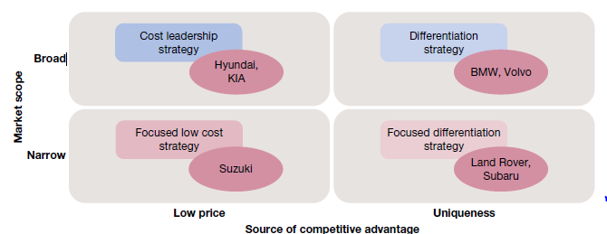

**Fig :: Porter’s generic strategies framework: motor vehicle industry examples**

According to Porter, business‐level strategic decisions are driven by two basic factors: (1) *market scope* and (2) *source of competitive advantage* — ask: ‘How will you compete for competitive advantage, by lower price or product uniqueness?’ . These factors combine to create the following four generic strategies that organisations can pursue. The examples in the figure are of competitive positions within the motor vehicle industry:

i. *differentiation* — where the organisation’s resources and attention are directed towards distinguishing its products from those of the competition (e.g. BMW, Volvo)

ii. *cost leadership* — where the organisation’s resources and attention are directed towards minimising costs to operate more efficiently than the competition (e.g. Hyundai, KIA)

iii. *focused differentiation* — where the organisation concentrates on one special market segment and tries to offer customers in that segment a unique product (e.g. Land Rover, Subaru)

iv. *focused cost leadership* — where the organisation concentrates on one special market segment and tries in that segment to be the provider with lowest costs (e.g. Suzuki)

Organisations pursuing a **differentiation strategy** seek competitive advantage through uniqueness. They try to develop goods and services that are clearly different from those made available by the competition. The objective is to attract customers who become loyal to the organisation’s products and lose interest in those of competitors. This strategy requires organisational strengths in marketing, research and development, technological leadership and creativity. It is highly dependent for its success on continuing customer perceptions of product quality and uniqueness.

Organisations pursuing a **cost leadership strategy** try to continuously improve the operating efficiencies of production, distribution and other organisational systems. The objective is to have lower costs than competitors and therefore achieve higher profits. This requires tight cost and managerial controls as well as products that are easy to manufacture and distribute. Of course, quality must not be sacrificed in the process. In fast food, McDonald’s remains the most cost‐effective operation of its type through preferential bulk‐purchasing agreements with suppliers, de‐skilled and often automated in‐house operations, and large customer volume providing economies of scale. It also uses one of the youngest and least expensive labour forces. It pays the minimum wage and keeps most staff on part‐time or casual employment, thereby escaping government requirements to pay superannuation and other statutory fulltime entitlements.

Organisations pursuing a **focused differentiation strategy** or a **focused cost leadership strategy** concentrate attention on a special market segment with the objective of serving its needs better than anyone else. The strategies focus organisational resources and expertise on a particular customer group, geographical region or product or service line. They seek to gain competitive advantage in product differentiation or cost leadership. Importantly, focused strategies require willingness to concentrate and the ability to use resources to special advantage in a single area.

5.Write a detailed note on Ethics, values and on views of ethical behaviour. [unit-5]

**Ethics** can be defined as the code of moral principles that sets standards of good or bad, or right or wrong, in a person’s conduct and thereby guides the behaviour of that person or group. These principles guide behaviour and help people make moral choices among alternative courses of action. In practice, **ethical behaviour** is that which is accepted to be ‘good’, ‘right’ and ‘proper’ as opposed to ‘bad’, ‘wrong’ or ‘improper’ in the context of the governing moral code.

## Law, values and ethical behaviour

It makes sense that there should be a legal component to ethical behaviour; that is, you would expect that any legal behaviour should be considered ethical. Furthermore, just because an action is not strictly illegal does not make it ethical. Living up to the ‘letter of the law’ is not sufficient to guarantee that your actions will or should be considered ethical. Is it truly .ethical, for example, for an employee to take longer than necessary to do a job? to make personal telephone calls on company time? to call in sick to take a day off for leisure? to fail to report rule violations by a co‐worker? None of these acts is strictly illegal, but many people would consider any one or all of them to be unethical. Most ethical problems in the workplace arise when people are asked to do, or find themselves about to do, something that violates the dictates of their conscience. For some, if the act is legal they proceed with confidence. For others, the ethical test goes beyond the legality of the act alone. The ethical question extends to personal **values** — the underlying beliefs and attitudes that help determine individual behaviour. Values vary among people.

## Alternative views of ethical behaviour

There are many different interpretations of what constitutes ethical behaviour. The first is the **utilitarian view**. Behaviour that would be considered ethical from this perspective delivers the greatest good to the greatest number of people. Founded in the work of 19th century philosopher John Stuart Mill, this is a results oriented point of view that tries to assess the moral implications of decisions in terms of their consequences. Business decision makers, for example, are inclined to use profits, efficiency and other performance criteria to judge what is best for the most people. A manager may make a utilitarian decision to cut 30 per cent of a factory’s workforce in order to keep the factory profitable and save jobs for the remaining 70 per cent.

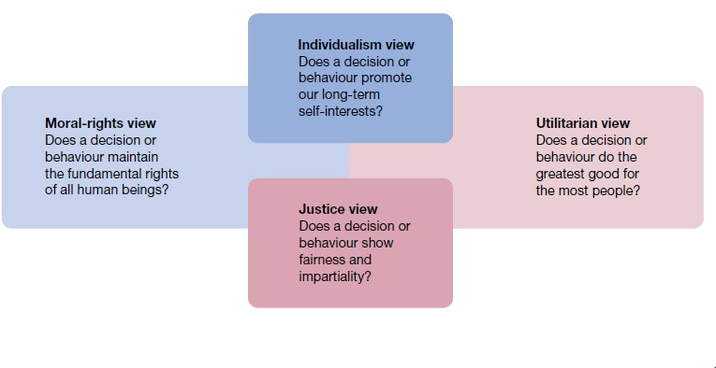

## Fig 5.6.1 Four views of ethical behaviour

The **individualism view** of ethical behaviour is based on the belief that our main commitment is to the advancement of long‐term self‐interests. When people pursue individual self‐interests, they supposedly become self‐regulating. For example, such things as lying and cheating for short‐term gain should not be tolerated. If one person does it, everyone will do it, and no‐one’s long‐term interests will be served. The individualism view is supposed to promote honesty and integrity. But in business practice it may result in a pecuniary ethic, described by one business executive as the tendency to ‘push the law to its outer limits’ and ‘run roughshod over other individuals to achieve one’s objectives.

Ethical behaviour under a **moral‐rights view** is that which respects and protects the fundamental rights of people. In many organisations today, this concept extends to ensuring that employees are always protected in their rights to privacy, due process, free speech, free consent, health and safety, and freedom of conscience. The issue of human rights, so characteristic of ethical concerns in the international business environment, is central to this perspective.

The United Nations stands by the Universal Declaration of Human Rights passed by the General Assembly in 1948. People are not a cost; they are a resource. Considerations for workers in and out of the workplace are the responsibility of the corporate leader just as much as the profits, survival, and growth of the business or organisation. Finally, the **justice view** of moral behaviour is based on the belief that ethical decisions treat people impartially and fairly according to guiding rules and standards. This approach evaluates the ethical aspects of any decision on the basis of whether it is ‘equitable’ for everyone affected. One justice issue in organisations is **procedural justice** — the degree to which policies and rules are fairly administered. A second issue is **distributive justice** — the degree to which outcomes are allocated without respect to individual characteristics based on ethnicity, race, gender, age or other criteria. A third issue is **interactional justice** — the degree to which others are treated with dignity and respect.

6.Explain in detail about the factors influencing ethical managerial behaviour. [unit-5]

## Factors influencing ethical behaviour

In practice, people are often challenged to choose ethical courses of action in situations where the pressures may be contradictory and great. Increased awareness of the factors influencing ethical behaviour can help in dealing with them more appropriately.

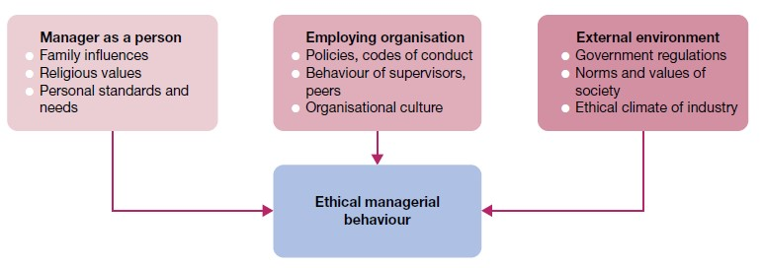

**Fig 5.6.3 Factors influencing ethical managerial behaviour — the person, organisation and environment**

## The person

Family influences, religious values, personal standards and personal needs, financial and otherwise, will help determine a person’s ethical conduct in any given circumstance. Managers who lack a strong and consistent set of personal ethics will find that their decisions vary from situation to situation as they strive to maximise self‐interests. Those who operate within strong ethical frameworks (personal rules or strategies for ethical decision‐making) will be more consistent and confident since choices are made against a stable set of ethical standards.

## The organisation

The organisation is another important influence on ethics in the workplace. The first port of call is at the staff selection stage. Unethical or unsavoury characters should not be recruited and appointed in the first instance. The expectations and reinforcement provided by peers and group norms are likely to have a similar impact. Formal policy statements and written rules are also very important in establishing an ethical climate for the organisation as a whole. They support and reinforce the organisational culture, which can have a strong influence on members’ ethical behaviour.

## The environment

Organisations operate in external environments composed of competitors, government laws and regulations, and social norms and values, among other influences. Laws interpret social values to define appropriate behaviours for organisations and their members; regulations help governments monitor these behaviours and keep them within acceptable standards. The climate of competition in an industry sets a standard of behaviour for those who hope to prosper within it. Sometimes the pressures of competition contribute further to the ethical dilemmas of managers.